­­­­­
HACK FOR IMPACT

TEAM ID : T20
TEAM Name : ABLE
TEAM members : 1)Tanaji Shirish Bodadkar
2)Samiksha Chandrashekar Barai
3)Apoorv Anant Khobragade

PS2: Accessible Financial Authorization for Inclusive and Verifiable Consent
Many users with low literacy, language barriers, or limited digital familiarity are required to approve financial actions such as loans, mandates, recurring payments, insurance terms, or consent-based onboarding flows without fully understanding their implications.
In many cases, consent is captured digitally but not meaningfully understood, creating risks of misinformed approvals, coercion, hidden obligations, and financial harm.
Build a solution that makes financial authorization more accessible, understandable, and trustworthy by improving how intent, obligations, and risk are communicated and confirmed before approval.
Solutions should prioritize inclusive interaction design, regional or multilingual accessibility, and mechanisms that strengthen confidence that consent was informed, deliberate, and verifiable rather than merely recorded.

LETS BRIDGE THE GAP!
GAP-
These gaps highlight that current systems prioritize consent collection over user comprehension, creating a critical need for an intelligent, inclusive, and verifiable authorization system.
Gap | How We Overcome It
Consent vs Understanding Gap | Provide simple, structured explanations before approval to ensure users understand terms instead of just clicking “Agree”.
Lack of Understanding Verification | Introduce an interactive quiz/confirmation step to verify user comprehension before allowing final consent.
Language Barrier | Enable multilingual support (Hindi, Marathi, English) so users can interact in their preferred language.
Hidden Risks and Obligations | Clearly highlight interest rates, penalties, and hidden charges using warnings, icons, and visual cues.
Non-Inclusive User Experience | Design an accessible interface with visuals, and minimal text for low-literacy and non-tech users.
Complex Financial Terminology | Convert technical terms into easy, real-life explanations using simplified language or AI-based logic.

System ARCHITECTURE
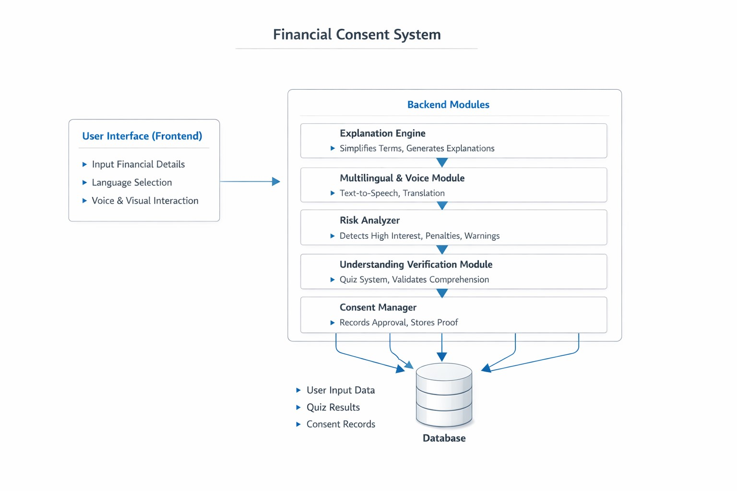

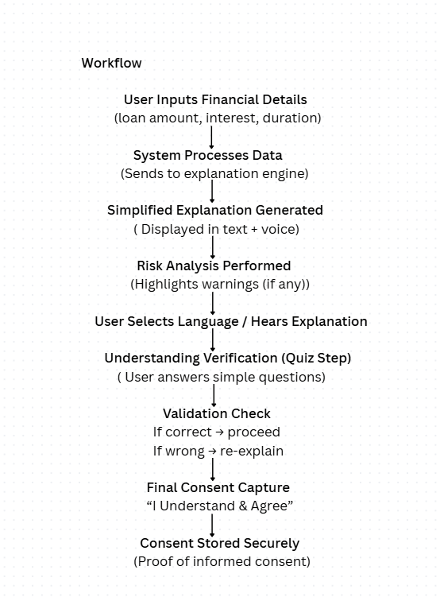

● The system ensures users understands - verify - then approve, making consent truly informed.

Technology USED:

Frontend Technologies
● HTML
Used to create the structure of the web application (login page, forms, dashboard, etc.)
● CSS
Used for designing UI (colors, layout, responsiveness, themes)
● JavaScript
Handles all logic like:
○ Login validation
○ Step navigation
○ EMI calculation
○ Dashboard updates
○ API calls

Data Visualization
● Chart.js
Used to create the donut chart for budget distribution (income, expenses, EMI)

Backend / API Integration
Google Gemini API
Used to provide AI-powered financial insights and responses.
● Takes user queries (e.g., “How to save more?”)
● Analyzes financial data (income, expenses, EMI)
● Generates intelligent suggestions in real-time
Flask (or your backend framework)
Used to:
● Create API endpoints (like /ask-ai)
● Handle requests from frontend
● Send data to Gemini API and return responses

AI Integration
● AI Chat System (Custom API)
○ Takes user queries like “How to save more?”
○ Returns financial suggestions
○ Likely connected to a backend (e.g., Python/Flask or Node.js)

Future Scope
● user authentication + DB
● credit score integration
● loan risk prediction
● financial fraud detection
● personalized budgeting plans
● investment recommendations

Expected Impact
FinSight improves:
● financial literacy
● debt awareness
● smarter savings
● accessible AI guidance
especially for regional-language users.

FinSight — Key Features
● AI Financial Assistant – Personalized finance advice and chat support using Google Gemini API.
● Multilingual Support – Available in English, Hindi, and Marathi.
● Income & Expense Tracking – Track monthly income, expenses, EMI, and savings.
● Loan EMI Calculator – Add multiple loans and calculate EMI automatically.
● Wealth Dashboard – Visual financial breakdown using Chart.js charts.
● Instant PDF Summarizer – Upload financial PDFs and get quick summaries.
● PDF Summarization Tech Used – PDF.js – Used to read and scan uploaded PDFs directly in the browser.
● Quick AI Insights – Instant profile-based financial suggestions and recommendations.

